**Action 1: Allows to add a user**

* Sending POST request to insert data:

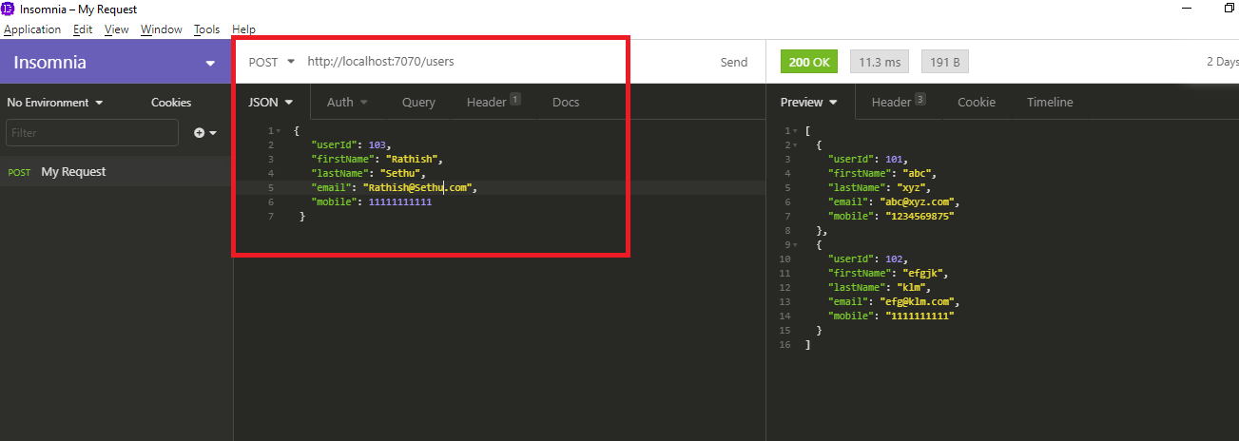

* Record has been inserted successfully

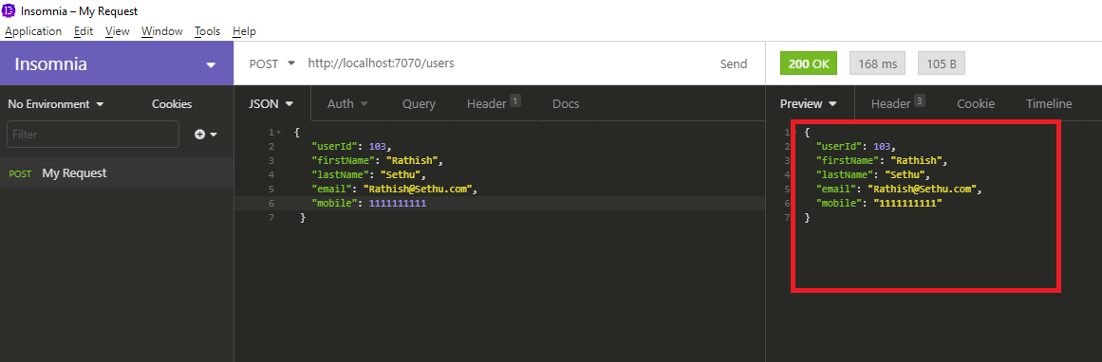

* Check the record insertion using GET request

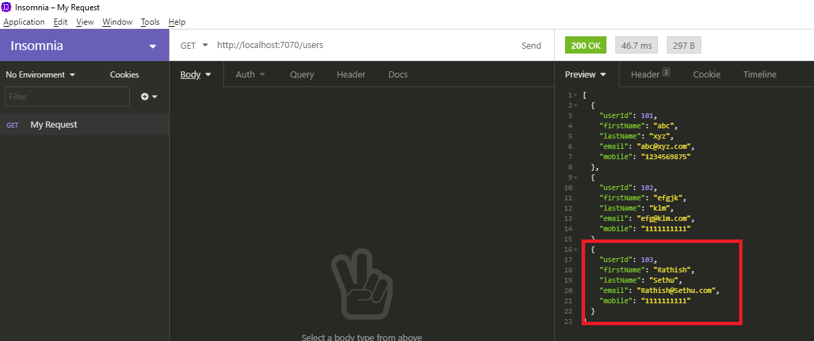

**Action 2: Allows to delete an existing user**

* Delete record number “102” using delete command

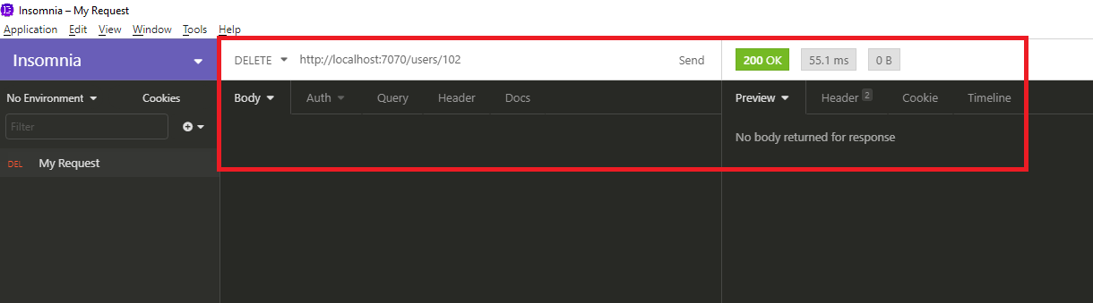

* Check the record deletion using GET request

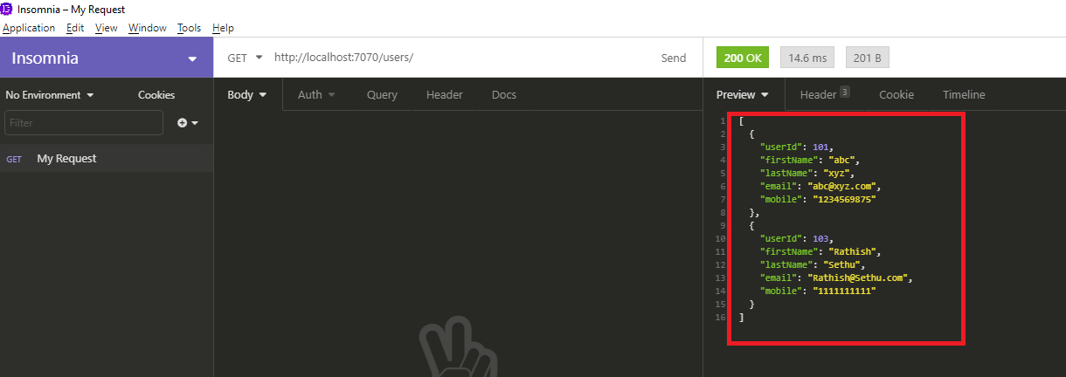

**Action 3: Allows to display all the users**

* Get request to display all users

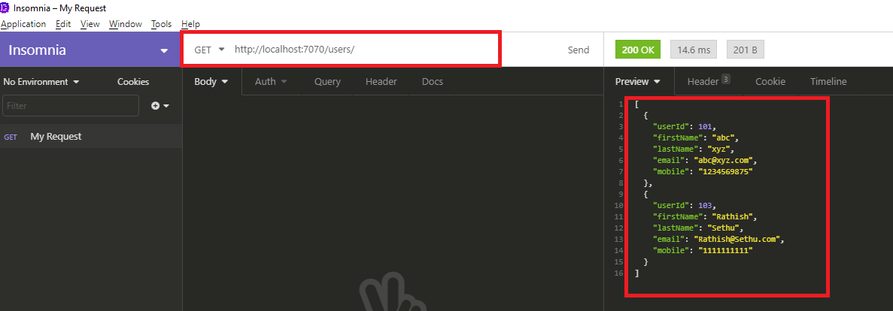

**Action 4: Allow to add interview**

* Sending POST request to insert data:

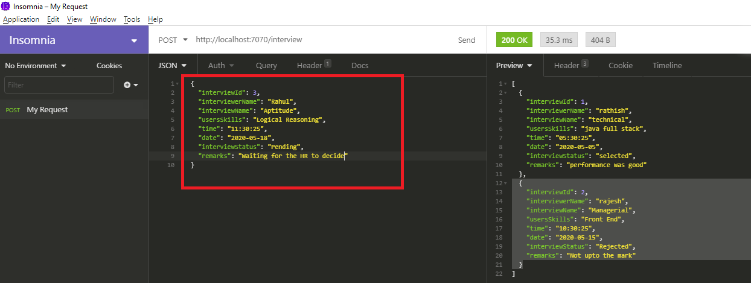

* Record has been inserted successfully

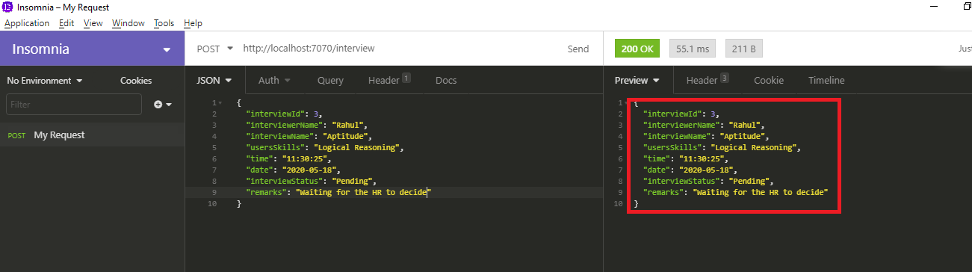

* Check the record insertion using GET request

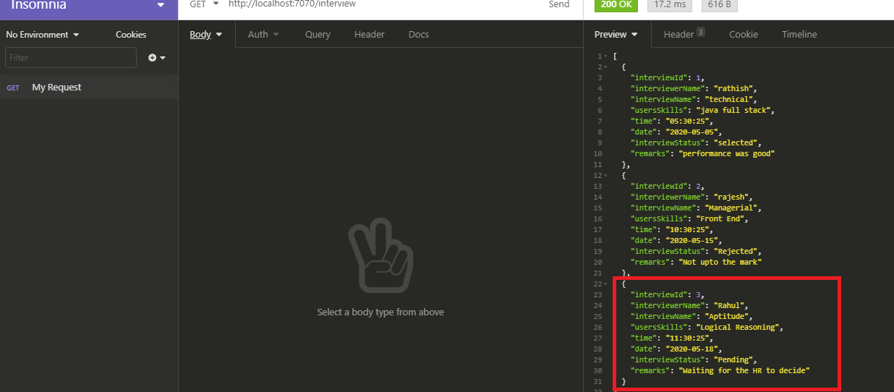

**Action 5: Allow to delete an existing interview**

* Delete record number “2” using delete command

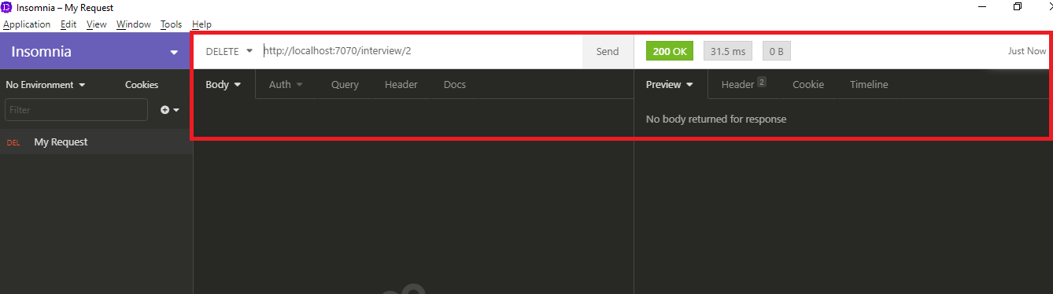

* Check the record deletion using GET request

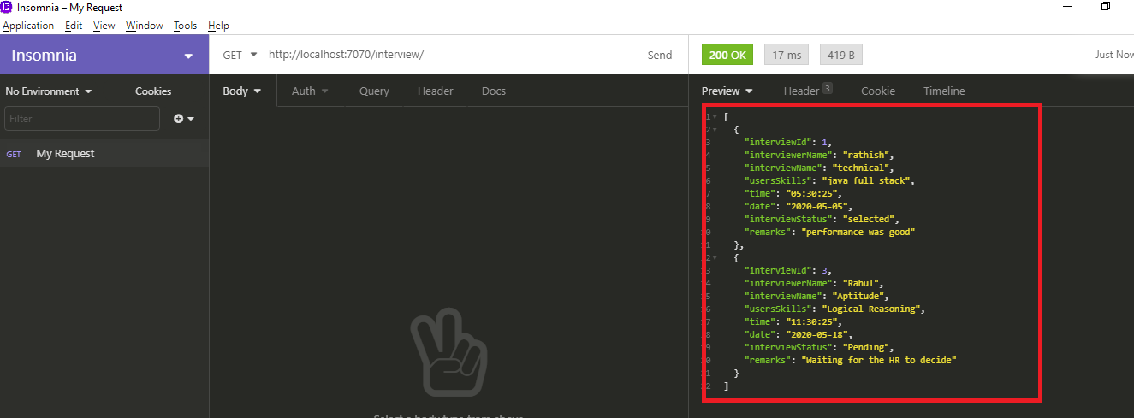

**Action 6: Allow to update interview status on go**

* Use PUT request to update the interview status of id-3 from Pending to selected

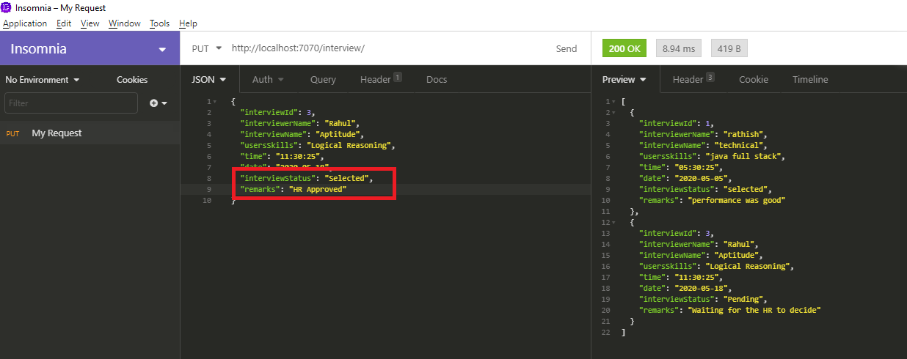

* Record has been updated successfully

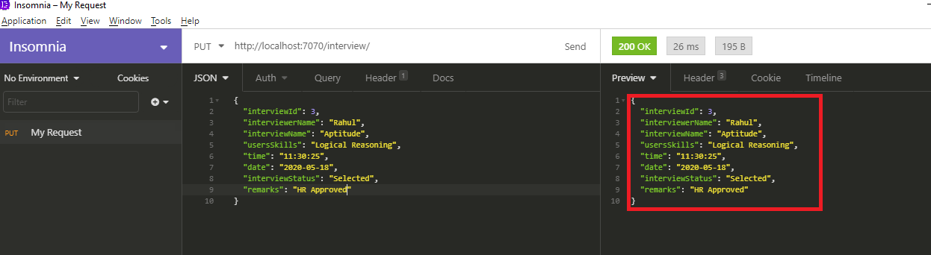

* Check the record update using GET request

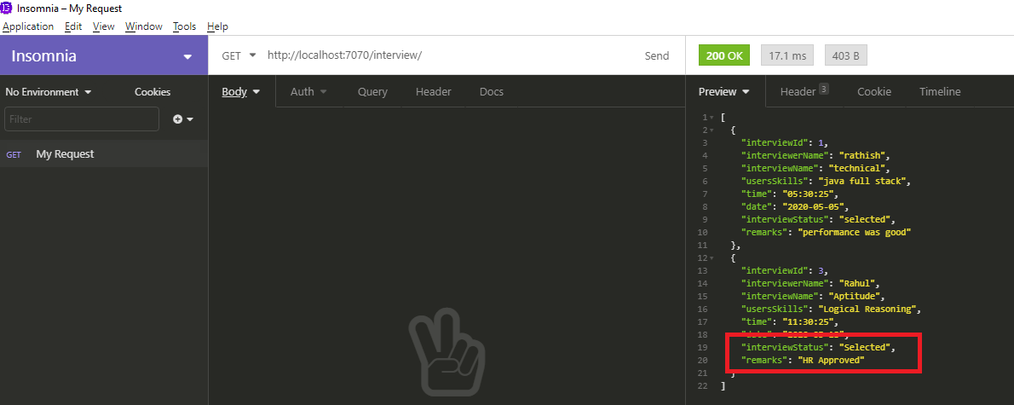

**Action 7: Allows to search the interview on the basis of Interview Name and Interviewer Name**

* Search the interview “Technical” using GET request

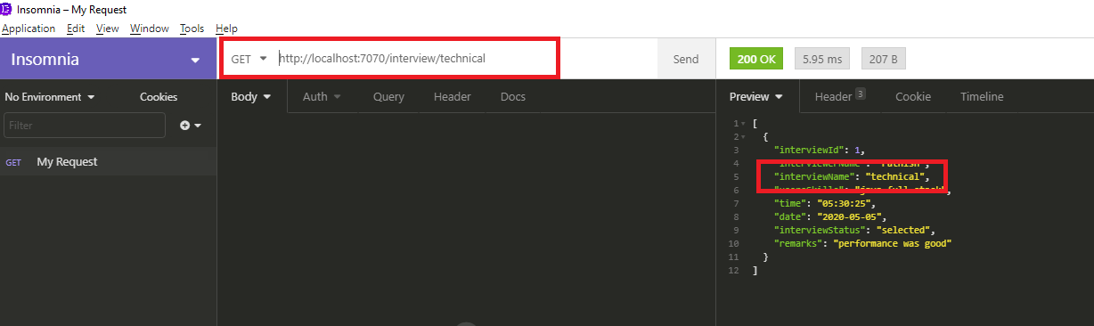

**Action 8: Allows searching total no of count of interview.**

* Get the total count using GET request

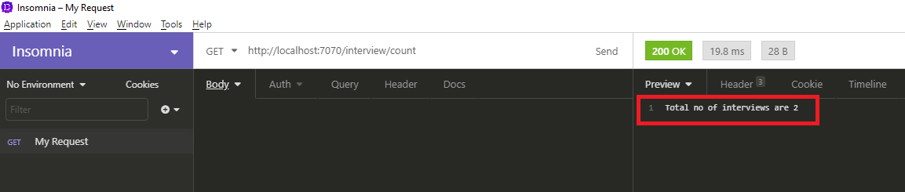

**Action 9: Allows to display all the interviews**

* Display all interviews using GET request

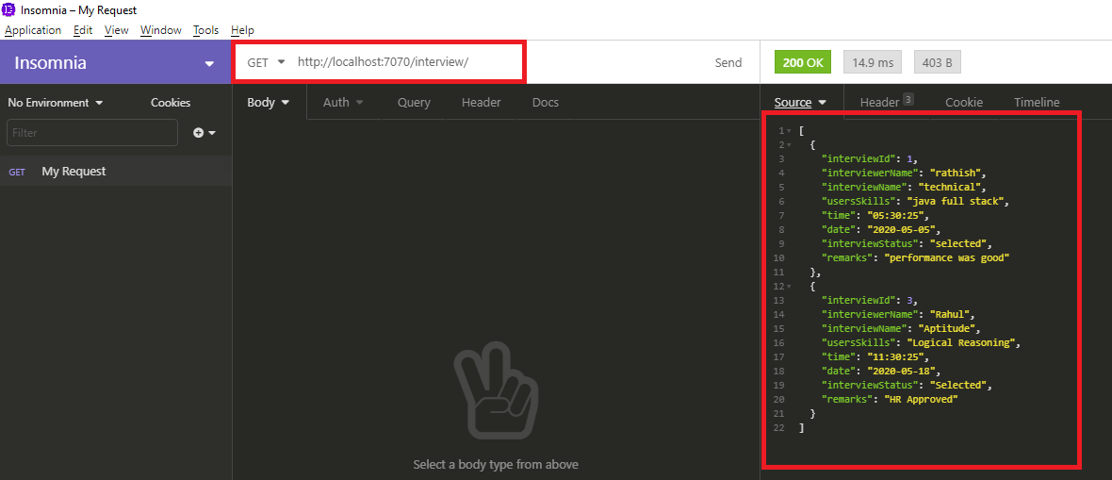

**Action 10: Allow to add attendee to an interview**

* Unable to add through Insomnia. Getting below error. Therefore, added through MySQL

